Assignment Title:

Role of Allama Iqbal in the Development of the Ideology of the Subcontinent

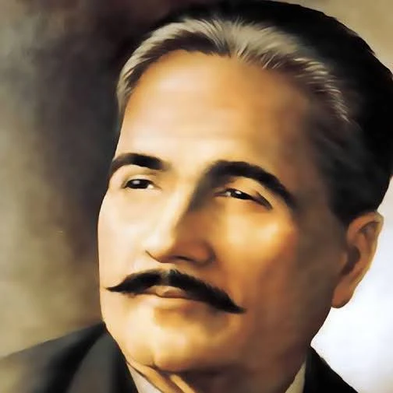
Introduction:
Allama Muhammad Iqbal is remembered as one of the most influential reformers and thinkers in the history of the Indian subcontinent. He was not only a poet and philosopher but also a political thinker who deeply influenced the ideology of Muslims in India (Rashid, 2018). During his time, Muslims were facing a crisis of identity, political weakness, and spiritual decline. Iqbal realized that unless Muslims rediscovered their faith and dignity, they could not survive as a separate community with a distinct identity. His mission was to awaken the Muslim Ummah, make them aware of their potential, and guide them toward unity and self-respect. His thoughts laid the foundation for what later became the ideology of Pakistan.

Early Life and Education:
Iqbal was born on November 9, 1877, in Sialkot, Punjab, into a religious and educated family. His father, Sheikh Noor Muhammad, was a devout man, and his mother, Imam Bibi, was known for her kindness and piety. These early influences played a major role in shaping Iqbal’s character and love for learning. He received his early education in Sialkot before joining Government College Lahore, where he came under the guidance of Sir Thomas Arnold. Arnold encouraged Iqbal to study philosophy and literature, which helped him develop a critical and thoughtful mind (Ali, 2019). Later, he went abroad for higher education, studying at Cambridge University, completing a law degree from Lincoln’s Inn in London, and earning a PhD in philosophy from the University of Munich, Germany. His doctoral thesis, The Development of Metaphysics in Persia, reflected his deep understanding of Islamic philosophy and thought (Hussain, 2015). During his time in Europe, he observed the material progress of Western civilization, but he also realized that their spiritual and moral values were lacking. This contrast strengthened his belief that Muslims could only progress if they combined faith with knowledge.

Iqbal as a Reformer:
One of Iqbal’s greatest contributions as a reformer was the concept of Khudi, which can be understood as selfhood or self-realization. He believed that every individual has a divine spark and potential within, and recognizing this inner strength was essential for personal and collective development (Saeed, 2021). Iqbal argued that Muslims had lost their self-respect due to centuries of subjugation and dependence, and the only way to regain their power was through the development of Khudi. His poetry, especially in works like Bang-e-Dara, Bal-e-Jibril, and Zarb-e-Kalim, emphasized self-awareness, courage, and responsibility (Iqbal, 1934). In these works, Iqbal often urged the youth to rise above fear and mediocrity, instilling a sense of pride and purpose. For example, in one of his famous verses he said,
“خود ہی کو کر بلند اتنا کہ ہر تقدیر سے پہلے
خدا پوچھے بندے سے کہ تیری رضا کیا ہے؟”
Meaning that one should elevate oneself so high that even destiny seeks their permission (Zafar, 2019). This concept of self-realization was not just philosophical; it was practical guidance for Muslims to regain their dignity and take control of their destiny.

Political Contributions and the Idea of Pakistan:
Iqbal’s role extended beyond philosophy and poetry; he was a political reformer who recognized the necessity of political organization for the survival of Muslims in the subcontinent. During British rule, Muslims were a minority and politically fragmented, whereas the Hindu majority was organized under the Indian National Congress. Iqbal understood that without political awareness, Muslims could not protect their identity and rights. In 1930, he delivered his famous Allahabad Address, where he proposed that the Muslims of northwestern India should have a separate homeland (Iqbal, 1930). He argued that Muslims were not merely a minority in India but a distinct nation with their own religion, culture, and social system, and thus deserved political autonomy (Rashid, 2018). Through this address, Iqbal provided the ideological justification for the Two-Nation Theory, which later became the guiding principle for the creation of Pakistan.
Iqbal also influenced leaders of his time, particularly Quaid-e-Azam Muhammad Ali Jinnah. He corresponded with Jinnah, encouraging him to return to politics and lead Muslims in their struggle for identity and independence (Malik, 2020). These letters were not merely political advice; they were philosophical and spiritual guidance, emphasizing the importance of faith, moral integrity, and vision. Many historians believe that Iqbal’s influence played a decisive role in shaping Jinnah’s leadership and Pakistan’s political movement. Through his efforts, Iqbal helped build unity among Muslims and motivated them to think collectively about their destiny.

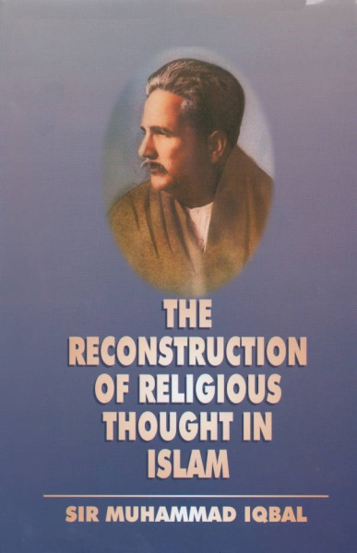
Educational and Cultural Reforms:
A key aspect of Iqbal’s reformist vision was his emphasis on Ijtihad, or independent reasoning in Islam. He argued that Muslims should not blindly follow old customs or interpretations but should use intellect to understand and apply Islamic teachings according to contemporary circumstances (Iqbal, 1930). This idea was revolutionary because it encouraged intellectual freedom within Islamic thought while remaining rooted in faith. It helped Muslims reconcile tradition with modernity, showing that religious principles could coexist with scientific and technological advancement. Iqbal’s lectures, compiled in The Reconstruction of Religious Thought in Islam, elaborated on how Islamic philosophy could provide moral and intellectual guidance in the modern world (Iqbal, 1930).
Iqbal also criticized the colonial education system for neglecting religion and morality. He believed that Muslims needed an education that combined spiritual guidance with practical knowledge to prepare them for leadership and nation-building (Ali, 2019). Through his writings and poetry, Iqbal encouraged young Muslims to pursue knowledge in science, literature, and philosophy while remaining true to Islamic values. His literary works transformed Urdu and Persian poetry from purely romantic or personal expressions into tools of reform and social awakening.

Impact and Legacy:
The impact of Allama Iqbal’s ideas on the subcontinent’s ideology was profound. He awakened Muslims to the realization that they were a distinct nation with their own identity and destiny. His vision of a Muslim state based on Islamic principles provided the intellectual and moral foundation for Pakistan. The ideological underpinnings of Pakistan, such as the sovereignty of Allah, justice, equality, and moral governance, can be traced directly to Iqbal’s philosophy (Saeed, 2021). He emphasized that faith and knowledge, spirituality and action, were all necessary for a strong and independent society. His ideas not only influenced political leaders but also inspired ordinary people to value education, unity, and self-respect.
Iqbal’s legacy continues to inspire generations. Pakistan celebrates Iqbal Day every year on November 9th; honoring his contributions to the nation and keeping his ideological vision alive (Govt. of Pakistan, 2022). His poetry and philosophy remain an essential part of education in Pakistan, reminding citizens of the importance of faith, self-respect, and national unity.

Conclusion:
In conclusion, Allama Iqbal’s role in developing the ideology of the subcontinent cannot be overstated. His philosophical and literary efforts awakened a sleeping Muslim nation, gave them a sense of identity, and prepared the intellectual and spiritual grounds for Pakistan. He was a reformer whose work combined religion, philosophy, education, and politics to create a coherent ideological vision. His message of self-realization, unity, and moral strength continues to guide Muslims today. Truly, Pakistan was first born in the mind and heart of Allama Iqbal, long before it became a political reality (Malik, 2020).

References:
- Ali, S. (2019). The Life and Philosophy of Allama Iqbal. Lahore: Sang-e-Meel Publications.
- Govt. of Pakistan. (2022). Allama Iqbal Day Celebration Report. Islamabad: Ministry of Information.
- Iqbal, M. (1930). The Reconstruction of Religious Thought in Islam. Lahore: Oxford University Press.
- Iqbal, M. (1934). Bal-e-Jibril. Lahore: Sheikh Ghulam Ali & Sons.
- Malik, A. (2020). Ideological Roots of Pakistan. Karachi: National Book Foundation.
- Rashid, K. (2018). Ideology of Pakistan. Islamabad: National Book Foundation.
- Saeed, F. (2021). Iqbal’s Philosophy of Khudi and Its Relevance Today. Karachi: University of Karachi Press.

